Chapter 13, Solution 35.

For mesh 1,

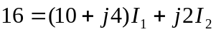 (1)

For mesh 2, 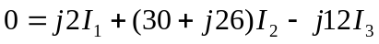 (2)

For mesh 3, 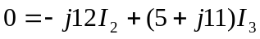 (3)

We may use MATLAB to solve (1) to (3) and obtain

I₁ 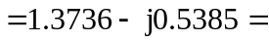 1.4754∠–21.41° A
I₂ 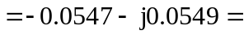 77.5∠–134.85° mA
I₃ 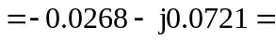 77∠–110.41° mA

1.4754∠–21.41° A, 77.5∠–134.85° mA, 77∠–110.41° mA

